**Battle of Neighborhoods - Presentation**

**Business Problem :**

Toronto is the provincial capital of Ontario and the most populous city in Canada, with a population of around 2.93 million as of 2017.

Imagine if someone want to open a Yoga Studio in Toronto, in which neighborhood(s), should they open so it is beneficial to people and profitable to the owner?

It will definitely have to be a neighborhood, which currently doesn’t have a Yoga Studio.

We want to explore, segment the neighborhoods in Downtown Toronto, to find such neighborhoods. However, unlike New York, the neighborhood data is not readily available on the internet.

For the Toronto neighborhood data, a Wikipedia page exists that has all the information we need to explore and cluster the neighborhoods in Toronto : [**https://en.wikipedia.org/wiki/List_of_postal_codes_of_Canada:_M**](https://en.wikipedia.org/wiki/List_of_postal_codes_of_Canada:_M)

The aim of this report is to study and analyze the neighborhoods of Toronto and filter the ones that currently have a Yoga Studio, so we know the ones that are remaining are the ones of interest.

**Data to be used :**

1.Scrape the Wikipedia page [**https://en.wikipedia.org/wiki/List_of_postal_codes_of_Canada:_M**](https://en.wikipedia.org/wiki/List_of_postal_codes_of_Canada:_M)into a dataframe :

df=pd.read_html('https://en.wikipedia.org/wiki/List_of_postal_codes_of_Canada:_M')[0]

df.head(10)

|  | **Postal Code** | **Borough** | **Neighborhood** |
| --- | --- | --- | --- |
| **0** | M1A | Not assigned | NaN |
| **1** | M2A | Not assigned | NaN |
| **2** | M3A | North York | Parkwoods |
| **3** | M4A | North York | Victoria Village |
| **4** | M5A | Downtown Toronto | Regent Park, Harbourfront |
| **5** | M6A | North York | Lawrence Manor, Lawrence Heights |
| **6** | M7A | Downtown Toronto | Queen's Park, Ontario Provincial Government |
| **7** | M8A | Not assigned | NaN |
| **8** | M9A | Etobicoke | Islington Avenue |
| **9** | M1B | Scarborough | Malvern, Rouge |

2. Drop the rows where a borough is not assigned

3. Read the geospatial co-ordinates of each postal code into a dataframe

df1=pd.read_csv('http://cocl.us/Geospatial_data/Geospatial_Coordinates.csv')

df1.head(10)

|  | **Postal Code** | **Latitude** | **Longitude** |
| --- | --- | --- | --- |
| **0** | M1B | 43.806686 | -79.194353 |
| **1** | M1C | 43.784535 | -79.160497 |
| **2** | M1E | 43.763573 | -79.188711 |
| **3** | M1G | 43.770992 | -79.216917 |
| **4** | M1H | 43.773136 | -79.239476 |
| **5** | M1J | 43.744734 | -79.239476 |
| **6** | M1K | 43.727929 | -79.262029 |
| **7** | M1L | 43.711112 | -79.284577 |
| **8** | M1M | 43.716316 | -79.239476 |
| **9** | M1N | 43.692657 | -79.264848 |

4. Merge the geospatial codes into the dataframe which has the neighborhoods and boroughs based on the postal codes

|  | **Postal Code** | **Borough** | **Neighborhood** | **Latitude** | **Longitude** |
| --- | --- | --- | --- | --- | --- |
| **0** | M3A | North York | Parkwoods | 43.753259 | -79.329656 |
| **1** | M4A | North York | Victoria Village | 43.725882 | -79.315572 |
| **2** | M5A | Downtown Toronto | Regent Park, Harbourfront | 43.654260 | -79.360636 |
| **3** | M6A | North York | Lawrence Manor, Lawrence Heights | 43.718518 | -79.464763 |
| **4** | M7A | Downtown Toronto | Queen's Park, Ontario Provincial Government | 43.662301 | -79.389494 |
| **5** | M9A | Etobicoke | Islington Avenue | 43.667856 | -79.532242 |
| **6** | M1B | Scarborough | Malvern, Rouge | 43.806686 | -79.194353 |
| **7** | M3B | North York | Don Mills | 43.745906 | -79.352188 |
| **8** | M4B | East York | Parkview Hill, Woodbine Gardens | 43.706397 | -79.309937 |
| **9** | M5B | Downtown Toronto | Garden District, Ryerson | 43.657162 | -79.378937 |
| **10** | M6B | North York | Glencairn | 43.709577 | -79.445073 |

**Methodology :**

1. Filter data for borough of Downtown Toronto and then create map of Toronto and mark Neighborhoods using Folium.

|  | **Postal Code** | **Borough** | **Neighborhood** | **Latitude** | **Longitude** |
| --- | --- | --- | --- | --- | --- |
| **0** | M5A | Downtown Toronto | Regent Park, Harbourfront | 43.654260 | -79.360636 |
| **1** | M7A | Downtown Toronto | Queen's Park, Ontario Provincial Government | 43.662301 | -79.389494 |
| **2** | M5B | Downtown Toronto | Garden District, Ryerson | 43.657162 | -79.378937 |
| **3** | M5C | Downtown Toronto | St. James Town | 43.651494 | -79.375418 |
| **4** | M5E | Downtown Toronto | Berczy Park | 43.644771 | -79.373306 |

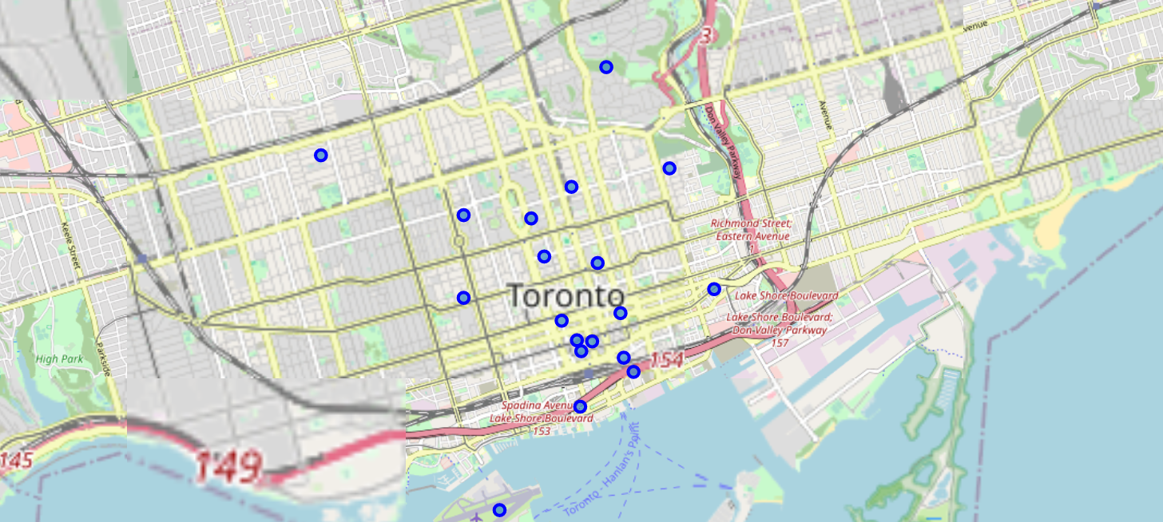

1. Explore the neighborhoods of Downtown Toronto using Foursquare API to get the different venues and venue category in each neighborhood. Snippet of Venue and Venue Category for a neighborhood.

|  | **Neighborhood** | **Neighborhood Latitude** | **Neighborhood Longitude** | **Venue** | **Venue Latitude** | **Venue Longitude** | **Venue Category** |
| --- | --- | --- | --- | --- | --- | --- | --- |
| **0** | Regent Park, Harbourfront | 43.65426 | -79.360636 | Roselle Desserts | 43.653447 | -79.362017 | Bakery |
| **1** | Regent Park, Harbourfront | 43.65426 | -79.360636 | Tandem Coffee | 43.653559 | -79.361809 | Coffee Shop |
| **2** | Regent Park, Harbourfront | 43.65426 | -79.360636 | Morning Glory Cafe | 43.653947 | -79.361149 | Breakfast Spot |
| **3** | Regent Park, Harbourfront | 43.65426 | -79.360636 | Cooper Koo Family YMCA | 43.653249 | -79.358008 | Distribution Center |
| **4** | Regent Park, Harbourfront | 43.65426 | -79.360636 | Body Blitz Spa East | 43.654735 | -79.359874 | Spa |

1. Create a dataframe which only has Venue category as 'Yoga Studio' and create list of unique Neighborhoods from it :

['Regent Park, Harbourfront',

"Queen's Park, Ontario Provincial Government",

'Central Bay Street',

'University of Toronto, Harbord',

'Stn A PO Boxes',

'Church and Wellesley']

1. The remaining neighborhoods, are the ones, to open a Yoga Studio

**Results:**

1. The neighborhoods identified in Step 4 above, are the ones where it would be benefical/profitable to open a Yoga Studio

|  | **Postal Code** | **Borough** | **Neighborhood** | **Latitude** | **Longitude** |
| --- | --- | --- | --- | --- | --- |
| **2** | M5B | Downtown Toronto | Garden District, Ryerson | 43.657162 | -79.378937 |
| **3** | M5C | Downtown Toronto | St. James Town | 43.651494 | -79.375418 |
| **4** | M5E | Downtown Toronto | Berczy Park | 43.644771 | -79.373306 |
| **6** | M6G | Downtown Toronto | Christie | 43.669542 | -79.422564 |
| **7** | M5H | Downtown Toronto | Richmond, Adelaide, King | 43.650571 | -79.384568 |
| **8** | M5J | Downtown Toronto | Harbourfront East, Union Station, Toronto Islands | 43.640816 | -79.381752 |
| **9** | M5K | Downtown Toronto | Toronto Dominion Centre, Design Exchange | 43.647177 | -79.381576 |
| **10** | M5L | Downtown Toronto | Commerce Court, Victoria Hotel | 43.648198 | -79.379817 |
| **12** | M5T | Downtown Toronto | Kensington Market, Chinatown, Grange Park | 43.653206 | -79.400049 |
| **13** | M5V | Downtown Toronto | CN Tower, King and Spadina, Railway Lands, Har... | 43.628947 | -79.394420 |
| **14** | M4W | Downtown Toronto | Rosedale | 43.679563 | -79.377529 |
| **16** | M4X | Downtown Toronto | St. James Town, Cabbagetown | 43.667967 | -79.367675 |
| **17** | M5X | Downtown Toronto | First Canadian Place, Underground city | 43.648429 | -79.382280 |

Conclusion :

In a fast moving world, there are many real life problems or scenarios where data can be used to find solutions to those problems. Like seen in the example above, data was used to filter neighborhoods in Toronto based on the venue = ‘Yoga Studio’ in those neighborhoods. Similarly, data can also be used to solve other problems, which most people face in metropolitan cities.

Reference :

[**https://en.wikipedia.org/wiki/List_of_postal_codes_of_Canada:_M**](https://en.wikipedia.org/wiki/List_of_postal_codes_of_Canada:_M)

<http://cocl.us/Geospatial_data/Geospatial_Coordinates.csv>

Foursquare API

THANK YOU!!